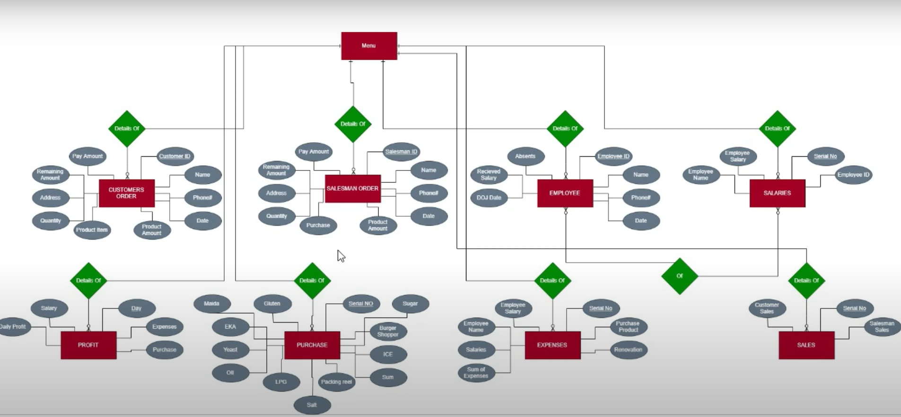

Workbench Project Workflow -

1. Database creation as per ER Model

2. Table development as per ER model

3. Solving problem statements with SQL Queries as below

\* Finding out repeat customers to generate specific offers

\* Finding out customers moved away with purchase pattern

\* development of performance metrics for the employees

\* Identification and Recognition of top performing employees

\* Identifying top selling products and market trends

These are few example problem statements , there will be many more based on the Database , every project will have 15-20 problem statements.